
BHARATHIDASAN UNIVERSITY
TIRUCHIRAPALLI 620 024

DETAILS OF PUBLICATIONS IN THE PEER-REVIEWED OR UGC-LISTED JOURNALS
FOR VERIFICATION AND RECOMMENDATION
FOR PROMOTION UNDER CAREER ADVANCEMENT SCHEME

PART – II FORM FOR CDOE FACULTY

Name of the Applicant :

Subject :

Address :

Mobile Number : e-mail id :

Present Designation :

Date of Last Promotion :

Application for the Post :

Date of Eligibility for
Present Promotion :

For Assistant Professor (Academic Level-10) To Assistant Professor (Senior Scale/Academic Level-11)

Details of Publications During the Assessment Period : DD.MM.YYYY -- DD.MM.YYYY
(Required 1 research paper in the Peer-reviewed or UGC-listed journals during the assessment period.)
(In the above provide DD.MM.YYYY -- DD.MM.YYYY)
TABLE -- I
S.No. | Names of all the authors and title of the publications | Name of the Journal and other details | Page numbers (in the enclosure) of the attached publication and supporting evidence of the concerned journal | Category*  (A) or (B) or (C) | Remarks by the verification Committee
 |  | Physical Review E, 2021, June, 105, 062110:1-8.  ISSN:  ESSN: | 21, 22 | (A) Web of Science
 |  |  |  | (B) DOAJ

If required number of publications is not made during the assessment period then give the details of publications after the assessment
Period in the following table.

Details of Publications After the Assessment Period (if necessary)
TABLE – II
S.No. | Names of all the authors and title of the publications | Name of the Journal and other details | Page numbers (in the enclosure) of the attached publication and supporting evidence of the concerned journal | Category*  (A) or (B) or (C) | Remarks by the verification Committee
 |  |  |  | (C) peer- reviewed journal

* Category: Mention the category as
(A) Web of Science, or (A) Scopus or (A) erstwhile UGC-CARE List or;
(B) DOAJ or (B) ERIC or (B) JSTOR or (B) ABDC database or;
(C) Peer- reviewed online/ printed journals. For Category (C), submit the filled in Table III given as Annexure for each journal separately.
For Assistant Professor (Senior Scale/Academic Level-11) To Assistant Professor (Selection Grade/ Academic Level-12)

Details of Publications During the Assessment Period : DD.MM.YYYY -- DD.MM.YYYY
(Required 3 research papers in the Peer-reviewed or UGC-listed journals during the assessment period.)
(In the above provide DD.MM.YYYY -- DD.MM.YYYY)
TABLE -- I
S.No. | Names of all the authors and title of the publications | Name of the Journal and other details | Page numbers (in the enclosure) of the attached publication and supporting evidence of the concerned journal | Category*  (A) or (B) or (C) | Remarks by the verification Committee
 |  | Physical Review E, 2021, June, 105, 062110:1-8.  ISSN:  ESSN: | 21, 22 | (A) Web of Science
 |  |  |  | (B) DOAJ

If required number of publications is not made during the assessment period then give the details of publications after the assessment
Period in the following table.

Details of Publications After the Assessment Period (if necessary)
TABLE – II
S.No. | Names of all the authors and title of the publications | Name of the Journal and other details | Page numbers (in the enclosure) of the attached publication and supporting evidence of the concerned journal | Category*  (A) or (B) or (C) | Remarks by the verification Committee
 |  |  |  | (C) peer- reviewed journal
* Category: Mention the category as
(A) Web of Science, or (A) Scopus or (A) erstwhile UGC-CARE List or;
(B) DOAJ or (B) ERIC or (B) JSTOR or (B) ABDC database or;
(C) Peer- reviewed online/ printed journals. For Category (C), submit the filled in Table III given as Annexure for each journal separately.
For Assistant Professor (SG/Academic Level-12) To Associate Professor (Academic Level-13A)

Details of Publications During the Assessment Period : DD.MM.YYYY -- DD.MM.YYYY
(Required 7 publications from the date of joining in the present institution to the end of the assessment period in the Peer-reviewed or UGC-listed journals out of which at least 3 research papers should have been published during the assessment period.)
(In the above provide DD.MM.YYYY -- DD.MM.YYYY)
TABLE -- IA
S.No. | Names of all the authors and title of the publications | Name of the Journal and other details | Page numbers (in the enclosure) of the attached publication and supporting evidence of the concerned journal | Category*  (A) or (B) or (C) | Remarks by the verification Committee
 |  | Physical Review E, 2021, June, 105, 062110:1-8.  ISSN:  ESSN: | 21, 22 | (A) Web of Science
 |  |  |  | (B) DOAJ

Details of Publications During the Period : DD.MM.YYYY (Date of joining in the present institution)
-- DD.MM.YYYY (the day before the last promotion)
TABLE -- IB
S.No. | Names of all the authors and title of the publications | Name of the Journal and other details | Page numbers (in the enclosure) of the attached publication and supporting evidence of the concerned journal | Category*  (A) or (B) or (C) | Remarks by the verification Committee
 |  | Physical Review E, 2021, June, 105, 062110:1-8.  ISSN:  ESSN: | 21, 22

If required number of publications is not made during the assessment period then give the details of publications after the assessment
Period in the following table.

Details of Publications After the Assessment Period (if necessary)
TABLE – II
S.No. | Names of all the authors and title of the publications | Name of the Journal and other details | Page numbers (in the enclosure) of the attached publication and supporting evidence of the concerned journal | Category*  (A) or (B) or (C) | Remarks by the verification Committee
 |  |  |  | (C) peer- reviewed journal

* Category: Mention the category as
(A) Web of Science, or (A) Scopus or (A) erstwhile UGC-CARE List or;
(B) DOAJ or (B) ERIC or (B) JSTOR or (B) ABDC database or;
(C) Peer- reviewed online/ printed journals. For Category (C), submit the filled in Table III given as Annexure for each journal separately.

For Associate Professor (Academic Level-13A) To Professor (Academic Level-14)

Details of Publications During the Assessment Period : DD.MM.YYYY -- DD.MM.YYYY
(Required 10 publications from the date of joining in the present institution to the end of the assessment period in the Peer-reviewed or UGC-listed journals out of which at least 3 research papers should have been published during the assessment period.)
(In the above provide DD.MM.YYYY -- DD.MM.YYYY)
TABLE -- IA
S.No. | Names of all the authors and title of the publications | Name of the Journal and other details | Page numbers (in the enclosure) of the attached publication and supporting evidence of the concerned journal | Category*  (A) or (B) or (C) | Remarks by the verification Committee
 |  | Physical Review E, 2021, June, 105, 062110:1-8.  ISSN:  ESSN: | 21, 22 | (A) Web of Science
 |  |  |  | (B) DOAJ

Details of Publications During the Period : DD.MM.YYYY (Date of joining in the present institution)
-- DD.MM.YYYY (the day before the last promotion)
TABLE -- IB
S.No. | Names of all the authors and title of the publications | Name of the Journal and other details | Page numbers (in the enclosure) of the attached publication and supporting evidence of the concerned journal | Category*  (A) or (B) or (C) | Remarks by the verification Committee
 |  | Physical Review E, 2021, June, 105, 062110:1-8.  ISSN:  ESSN: | 21, 22

If required number of publications is not made during the assessment period then give the details of publications after the assessment
Period in the following table.

Details of Publications After the Assessment Period (if necessary)
TABLE – II
S.No. | Names of all the authors and title of the publications | Name of the Journal and other details | Page numbers (in the enclosure) of the attached publication and supporting evidence of the concerned journal | Category*  (A) or (B) or (C) | Remarks by the verification Committee
 |  |  |  | (C) peer- reviewed online journal

* Category: Mention the category as
(A) Web of Science, or (A) Scopus or (A) erstwhile UGC-CARE List or;
(B) DOAJ or (B) ERIC or (B) JSTOR or (B) ABDC database or;
(C) Peer- reviewed online/ printed journals. For Category (C), submit the filled in Table III given as Annexure for each journal separately.

Instructions:

- Provide details of publications made in the journals under categories A or B or C only.
- Enclose the first page of each publication. The first page should clearly indicate the name of the journal, volume number, issue number and year of publication.
- Provide any one of the following evidence for the published research articles: (A) Web of Science/ Scopus / erstwhile UGC-CARE List or (B) in recognized databases, i.e. DOAJ/ ERIC/ JSTOR/ ABDC database or; (C) Peer- reviewed as per UGC suggestive parameters in Table III given as Annexure A (Refer Annexure B for sample evidence).
- For any article published in category (C) peer-reviewed online journal confirm that the journal is in compliance with UGC suggestive parameters given in Table III. Any cloned journal or a delisted journal shall not be considered as peer-reviewed journals. For any article published in category (C) peer-reviewed printed journal confirm that the journal is in compliance with UGC suggestive parameters given in Table III. Provide the details of the website clearly and the web page should clearly provide the evidences of UGC mandatory/ suggestive parameters. Any cloned journal or a delisted journal shall not be considered as peer-reviewed journals. The details of the concerned issue of the journal should be available in the website of the journal. The cover page, e-mail id and other details of the print journal issue available with the applicant should match with those in the issue of the concerned journal in the journal’s website, otherwise the concerned publication will not be considered as an original publication of the journal. For a print only journal submit original one copy of the issue containing the publication along with the application.
- For a publication in the start of the assessment year and the end of the assessment year provide evidence of the month of the publication. This is necessary.
- Any publication provided without proper evidence of it being in the Peer-reviewed or UGC-listed journals list will be treated as it is not a publication in the Peer-reviewed or UGC-listed journals.
- A Chapter in a Book Series covered in Scopus or Web of Science will not be considered as a journal publication.
- Don’t provide only the required number of publications. Provide all your publications in the Peer-reviewed or UGC-listed journals made in the concerned period mentioned in the tables.
- Provide 3 copies of PART – II Form (for all categories of promotion).
Annexure (To be filled for Category C)
Table III: UGC Suggestive Parameter
Name of the Journal:
Website Address:
No. | Evaluation Criteria | Classification | Yes | No
1.1 | Journal Title | Mandatory | ☐ | ☐
1.2 | ISSN Number (Print and/or Online) | Mandatory | ☐ | ☐
1.3 | Periodicity and Continuity (Regular publication schedule) with minimum of 07 years | Mandatory | ☐ | ☐
1.4 | Contact and Publication Details | Mandatory | ☐ | ☐
1.5 | Transparent Review Policy | Mandatory | ☐ | ☐
1.6 | Website on a Certified Domain | Mandatory | ☐ | ☐
1.7 | Open Access / Subscription Policy | Mandatory | ☐ | ☐
1.8 | Integration with Repositories (ONOS etc.) | Supportive | ☐ | ☐
1.9 | Archival Policy | Mandatory | ☐ | ☐
2.1 | Editorial Board Details | Mandatory | ☐ | ☐
2.2 | Editorial Board Composition | Mandatory | ☐ | ☐
2.3 | Efficient Editorial & Review Process | Mandatory | ☐ | ☐
3.1 | Aims, Objectives & Scope | Mandatory | ☐ | ☐
3.2 | Subject Areas Covered | Mandatory | ☐ | ☐
3.3 | APC Transparency (if any) | Mandatory | ☐ | ☐
3.4 | Publishing Timeline | Mandatory | ☐ | ☐
3.5 | Acceptance Rate | Supportive | ☐ | ☐
4.1 | Academic Contribution | Supportive | ☐ | ☐
4.2 | Conformity to Journal Scope | Supportive | ☐ | ☐
5.1 | Bibliographic Data & Literature Citation | Mandatory | ☐ | ☐
5.2 | Font & Design | Supportive | ☐ | ☐
5.3 | Infographics & Exhibits | Supportive | ☐ | ☐
5.4 | Citation Record | Supportive | ☐ | ☐
5.5 | Print Continuum | Supportive | ☐ | ☐
5.6 | Quality of Website | Supportive | ☐ | ☐
5.7 | Multilingual Availability | Supportive | ☐ | ☐
6.1 | Ethical Guidelines for Authors | Mandatory | ☐ | ☐
6.2 | Plagiarism Prevention | Mandatory | ☐ | ☐
6.3 | Conflict of Interest Disclosure | Mandatory | ☐ | ☐
6.4 | AI Generated Content Policy | Supportive | ☐ | ☐
7.1 | Impact Factor or Similar Metric | Supportive | ☐ | ☐
7.2 | Indexation in Reputed Databases | Supportive | ☐ | ☐
8.1 | Self-Citation Score | Supportive | ☐ | ☐
8.2 | Total Citation Rate | Supportive | ☐ | ☐
8.3 | Cite Score | Supportive | ☐ | ☐
 | Total Number of Eligible Mandatory Parameters
 | Total Number of Eligible Supportive Parameters

The UGC suggestive parameters is classified into mandatory and supportive categories. To be considered an eligible journal, the following conditions must be satisfied: (a) A minimum of 15 mandatory parameters shall be fulfilled; (b) A minimum of 5 supportive parameters shall be fulfilled. Tick the Relevant boxes based on the evidence available in the website.

CATEGORY A
Web of Science
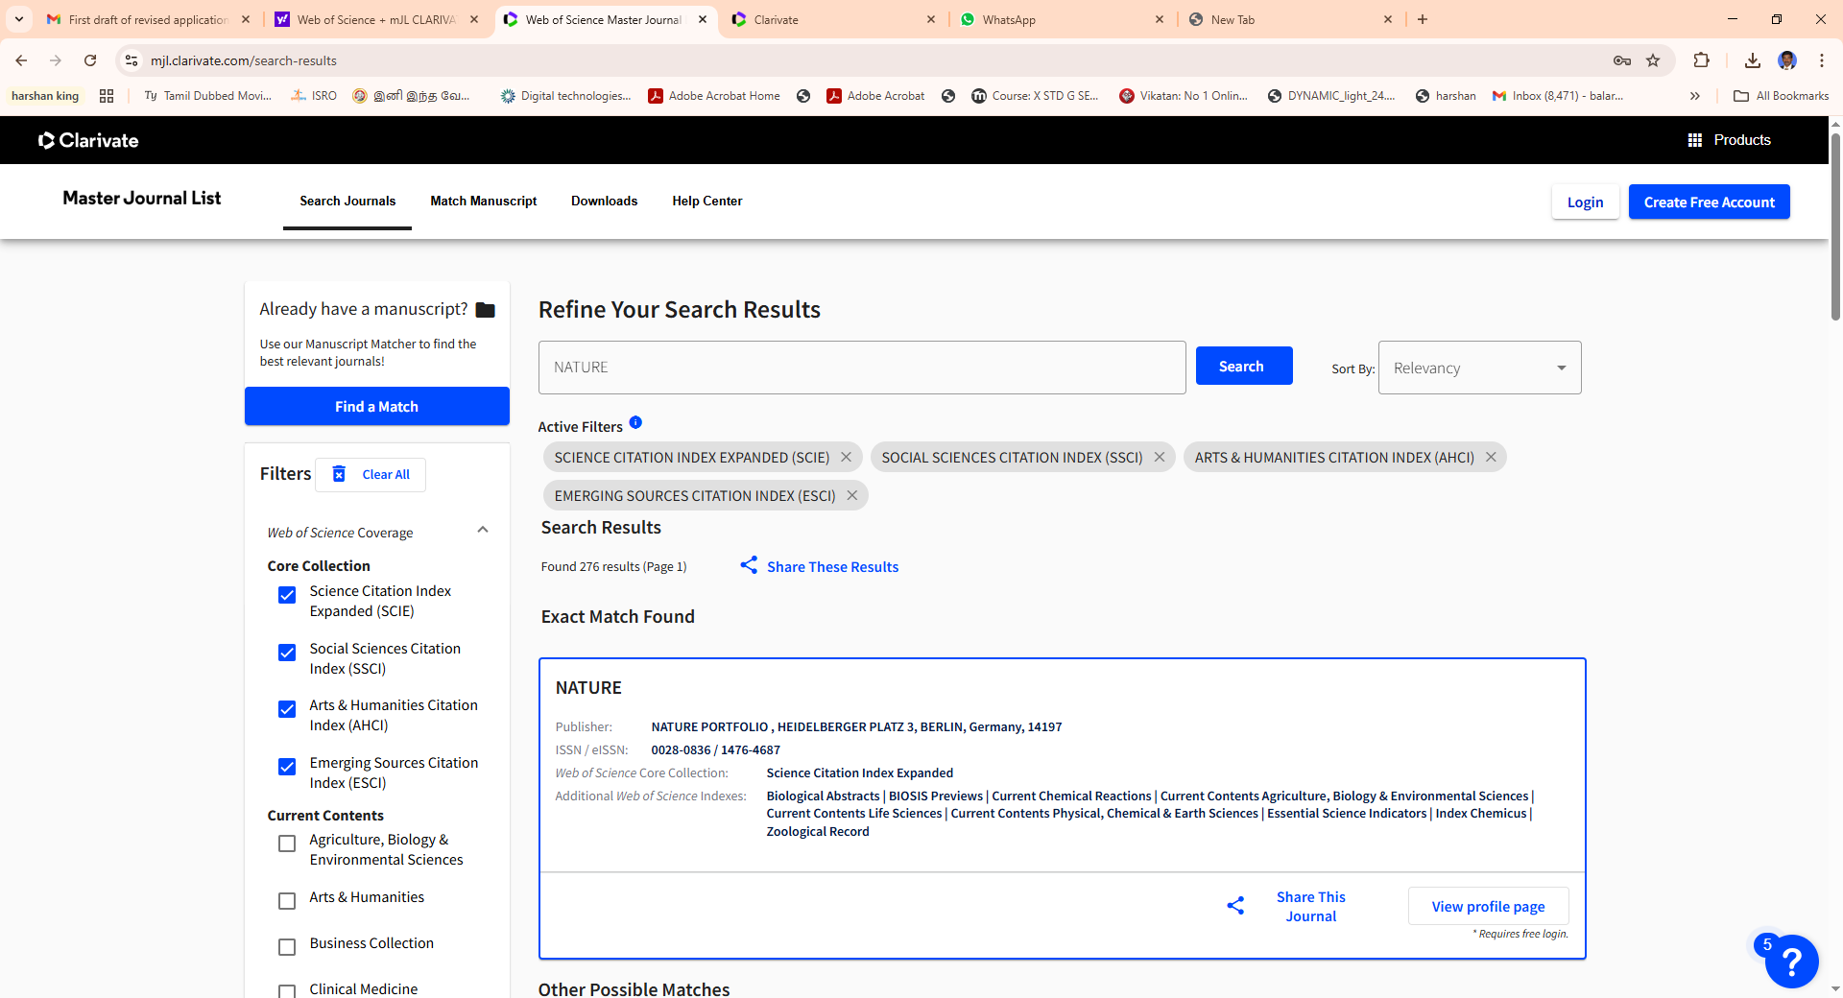

https://mjl.clarivate.com

CATEGORY A
Scopus
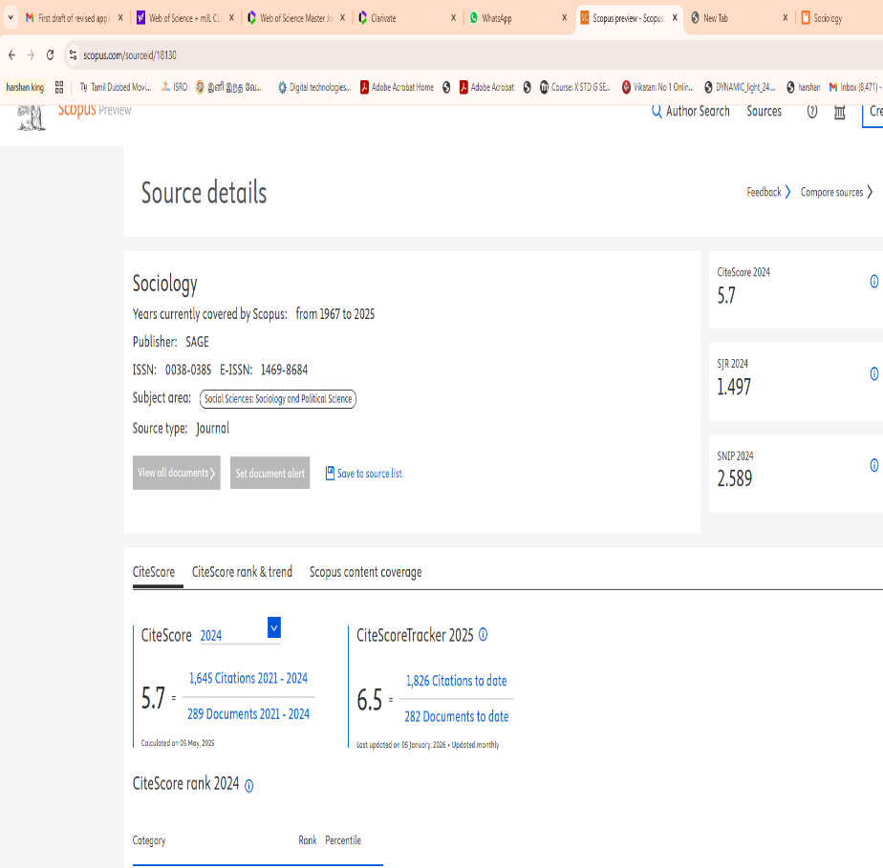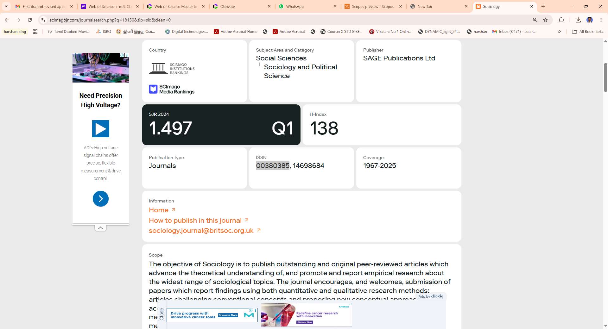
(https://www.scopus.com) (https://www.scimagojr.com)

CATEGORY A
Erstwhile UGC-CARE List

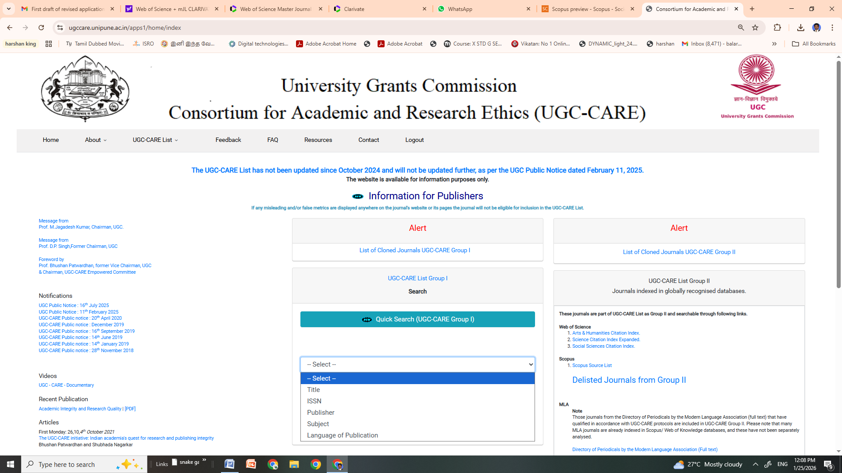

https://www.ugc.gov.in/e-book/Final_list_of_UGC-CARE_journals.pdf

CATEGORY B
Directory of Open Access Journals (DOAJ)

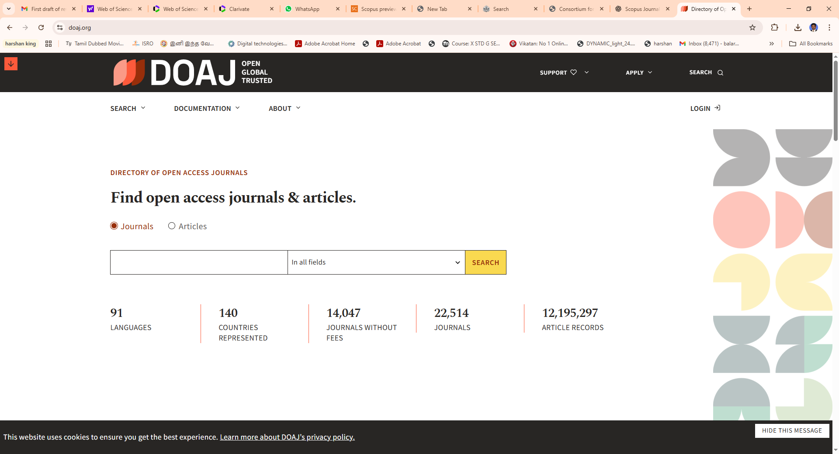

https://doaj.org/

CATEGORY B
ERIC database

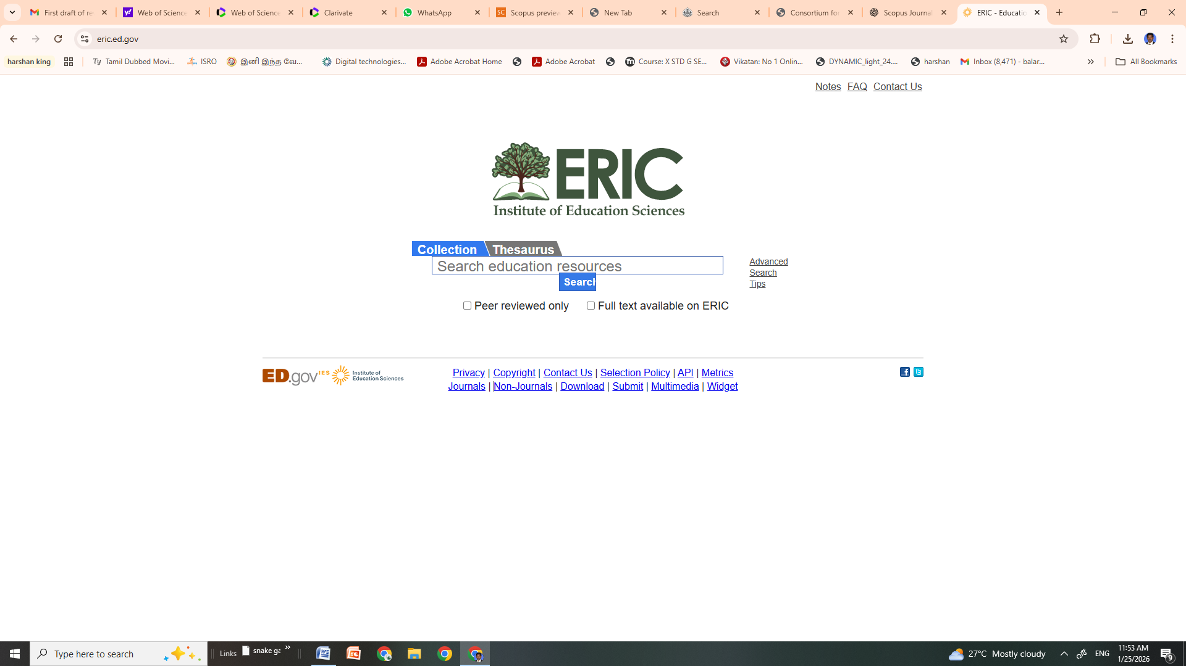

https://eric.ed.gov/

CATEGORY B
JSTOR

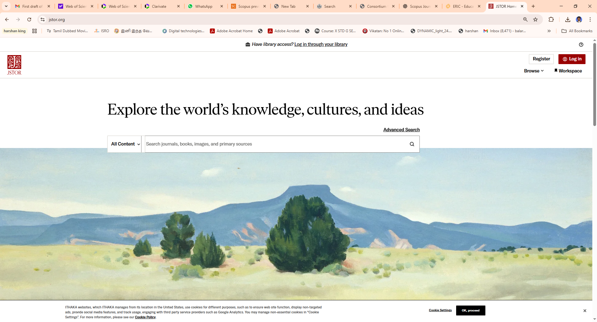

https://www.jstor.org/
CATEGORY B
ABDC Journals

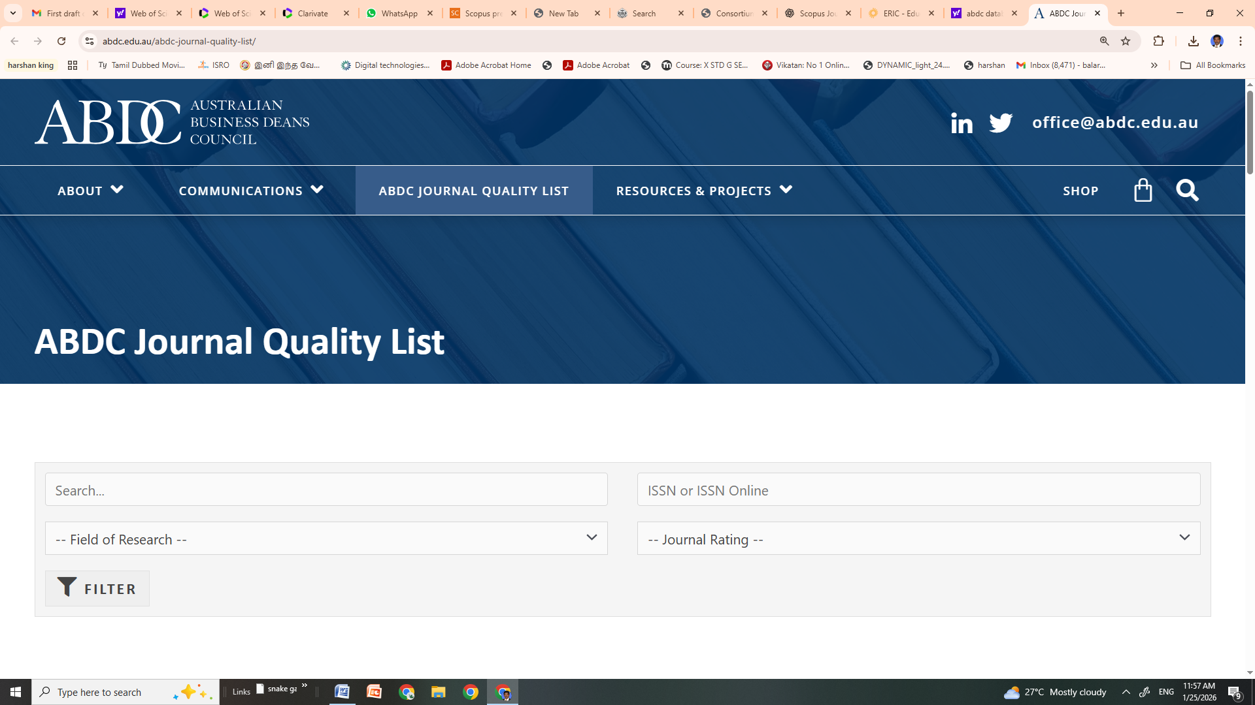

https://abdc.edu.au/abdc-journal-quality-list/

